###### 

Surface Attack Tactics (SAT) Handbook

494th vFS / 108th vFS / 388th vFS/ 617th vFS

Handbook

132nd Virtual Wing

[www.132virtualwing.org](http://www.132virtualwing.org/)

This work is licensed under a [Creative Commons Attribution-ShareAlike 3.0 Unported License](http://creativecommons.org/licenses/by-sa/3.0/).

Surface Attack Tactics (SAT) Handbook

|  |  |
| --- | --- |
| Applies to: | 494th vFS / 108th vFS / 388th vFS/ 617th vFS |
| Type: | **Handbook** |
| Version: | 0.7 |
| Published date: | 11.04.2020 |
| Document responsible: | Neck |
| summary of changes: | *v0.7: Major overhaul based on feedback. Added 494th Z-diagrams* |
| References: | *476th: 476TTP3.3.A10 -24APR16 (*[*LINK*](http://www.476vfightergroup.com/downloads.php?do=file&id=376&act=down&actionhash=guest)*)*  *Eddie, 476th Forums: Air-to-Surface Weapon Delivery Methods (*[*LINK*](http://www.476vfightergroup.com/showthread.php?3131-Air-to-Surface-Weapon-Delivery-Methods)*)*  *Andy Bush: Combat Mission Planning Considerations (*[*LINK*](http://www.simhq.com/_air/air_009a.html)*)*  *“Falcas”: Weapon Delivery Planner Manual by (*[*LINK*](https://burgers6.home.xs4all.nl/files/WDP1.3%20OF%20Manual.pdf)*)*  *Employment Fundamentals* *T-38C/Introduction To Fighter Fundamentals (* [*LINK*](https://drive.google.com/file/d/1wPc6qooae2fSvN5dCnXhXgLHyInSEqhq/view?usp=sharing)*)*  *VMAT - 203: Flight Syllabus Guide Maneuver Descriptions Ver. 3.0 (* [*LINK*](https://drive.google.com/file/d/1l-Pictc37WttFlaI55EaXEjei4ZA4AxJ/view?usp=sharing) *)* |

Contents

Introduction 4

**1.** **Planning your attack.** 5

**1.1.** **Target study** 5

**1.2.** **Weapon selection** 6

**1.3.** **Type of delivery** 6

**1.4.** **Final Attack Heading and Initial Point** 7

**1.5.** **Egress heading** 7

**1.6.** **Post attack rendezvous point** 7

**1.7.** **Attack tactics** 8

**1.7.1.** **Chooing attack tactics based on Acceptable Level of Risk (ALR)** 8

1.7.2. Tactics For A High Threat Environment 9

**1.7.3.** **Tactics For A Low Threat Environment** 9

**1.8.** Egress 10

**1.9.** **Contingencies** 10

**2.** **Tactics and Weapon Delivery Methods** 12

**2.1.** **Mission altitude profiles** 12

**2.2.** **Low altitude tactics** 14

**2.2.1.** **Gun deliveries** 16

**2.2.2.** **Low Level Deliveries** 17

**2.2.2.1.** **Pop-up attacks** 18

**2.3.** **Medium/high altitude tactics.** 20

**2.3.1.** **Medium and High Level Deliveries** 21

**3.** **Chapter 3: Two-Ship employment considerations** 23

**3.1.** **Pilot roles and assignments** 23

**3.2.** **Low Altitude two ship tactics and deconfliction** 24

Single or double attack directions 24

3.2.1. Time deconfliction 25

3.2.1.2. Loft Attacks 26

Simultaneous Loft 26

Loft on the Wing 26

Trail Loft 26

**3.3.** Laser Maverick (LMAV) (Left / Right) Attack 27

**3.4.** Off-Target Priorities 28

**4.** **Chapter 4: Useful information** 29

**4.1.** **Three Point Attack Brief** 29

**4.2.** **Fence Check** 29

**4.3.** **Mutual support Attack Geometry** 29

**4.4.** **Buddy lasing** 33

**4.5.** **Ground lasing** 33

**4.6.** **Holding patterns** 33

**4.7.** **Range pattern** 35

4.7.1. Conventional Pattern 35

4.7.2. Tactical Pattern 36

**4.8.** **Safe Escape Maneuvers (SEM)** 36

**5.** **Chapter 4: Z-Diagrams** 39

**5.1.** **Z-Diagrams 494th** 41

Low Altitude Toss (LAT) - (10 second tracking at 30 LALD) 43

Low Altitude 40° LOFT 44

40˚ High Altitude Release Bomb (HARB) 45

**5.2.** **Z-Diagrams 388th** 46

**5.3.** **Z-Diagrams 108th** 46

Surface attack is a challenging mission that requires complete knowledge of your aircraft systems, handling characteristics and ordnance. Given surface-to-air and air-to-air threats, the surface attack role is demanding. Surface Attack Tactics (SAT) is the tactics, techniques and procedures for conducting surface attacks effectively and safely.

# Introduction

Scope: This document outlines the Tactics Techniques and Procedures (TTP's) for surface attacks with fast jets in the 132nd Virtual Wing. Each squadron will have their own Standard Operating Procedures (SOP's) for aircraft squadron specifics in regards to surface attacks.

Content: This document is divided into 4 chapters. Chapter 1 describes planning for a successful surface attack. Chapter 2 contains tactics and weapon delivery methods. Chapter 3 contains useful information. The final chapter contains specific Z- diagrams with parameters for attack profiles for the various squadrons.

Pilot responsibility: Use common sense. TTP's describe technical and tactical procedures for most circumstances, but is no substitute for common sense and judgment. It is the pilot's responsibility to fly the aircraft safely and effectively in all circumstances, as required to accomplish the mission.

Deviations: Deviations from these TTP's are approved as long as they are communicated to all parties operating together.

Recommended changes: Improvements and recommended changes to this TTP should be stated to the Wing Command Staff.

You are a new flight lead, tasked to fly deep into enemy territory to bomb a building protected by SAM and AAAs How do you get to the target, how can you destroy it, and how do can you come back alive? This is the big questions for all strike missions.

How and what can you do?

One option is to avoid being seen. We can stay below the radar and pop up just before we drop our ordnance. This will give the enemy only a short time to track and thus a short time to aim and shoot at you. You could also stay above the threat and drop your bombs from a safe altitude. Maybe you could stay far away from the threats and toss the bomb to the target. But when do you go up? How high do you climb?

Planning is part of the answer. If you plan your attack, you will have better chances of surviving the mission. Mutual support and cooperation with your wingman and other flights is another part of the answer.

# **Planning your attack.**

What do we need? This is always a good question to start with. When you know what you need, you also know what you should be looking for. For a start we need to know what the target is. Is it a “point”, like a radar dish, or is it a long target like a bridge or building?

If it is a “point” it doesn’t matter from which direction you attack it. If it’s a long bridge you might want to think about attacking it along its axes. This way you can ripple your bombs in a “stick”. What is the elevation of the target? Is it on a mountain or at sea level? What is the threat that surrounds the target? Can you find a route around AAA and SAMs? What does the surrounding look like? There could be a mountain blocking your route during the attack or during the exit. Do we ingress at a low or a high altitude? As you can see, there is a lot to think about. This chapter will aid you through the process.

**NOTE:** Whilst all these facorts and guidelines are applicable during AR and CAS mission, the dynamic nature of these mission often deny you access to information beforehand.

## **Target study**

Prior to any mission you should gather all available information, maps, imagery and intelligence. Information can be found in various sources such as the mission brief, Air Tasking Order (ATO), target packs, DCS Mission Editor or Combat Flite.

You want to look at the overall target area. Use DCS Mission Editor or Combat Flite maps and various target photos to “see” the position of the target from a “big picture perspective.” This is very important. You might choose to approach your target at high speed and at low altitude, where your radius of vision is limited. Your attention will be split between navigation concerns and analysing, interpreting, and possibly responding to enemy threats.

Your “big picture” study has one purpose; you want to locate significant navigational references that you will use to “walk” your eyes to the target. As an explanation, let’s say the target is a truck convoy located near a bridge. As you run in to the immediate target area, you first locate the river. You follow the river until you get a tally on the bridge. You know from your target study that the truck convoy is situated in a particular direction from the bridge. Use your run in heading to the bridge as a twelve o’clock reference. Then translate the target’s location relative to the bridge into a clock position. For example, as you approach the bridge, you look to the bridge’s nine o’clock to find the target. Use this step-by-step process to get your eyes on the target in a methodical manner. Do not leave it to luck or chance to find your target. Your map and target photos make it possible to build your mental picture of this “big picture.” Using the “big picture to specific target” technique helps you find your target quickly, leaving you additional time to devote to achieving a successful one-pass attack.

Now, let’s consider what the target actually looks like. Use your maps and target photos to get a general picture of the target layout. See how long the target is. Then you can decide on ripple and spacing. Notice the colour of the target. This might help during the day. A dark building can be found nicely when it has a light background. Try to find out what the elevation of the target is. This will give you the first ideas of which attack profile to choose.

Using the convoy again as an example, determine if the convoy is strung out in a line or grouped together. Note the general compass orientation of the target. Determine if your attack heading will take you down the length of the convoy or across it. This heading is called your “attack axis.” Your weapon effectiveness is affected by your choice of attack axis. For example, when using CBU bomblets, you want to spread the bomblets along the length of the convoy rather than across it. Your target study may give you the location of that threat in the convoy.

If you are attacking a large target that requires several impacts, assess where the impact points should be placed. These becomes your DMPI (Desired Mean Point of Impact) for unguided weapons, and DPI ( Desired Point of Impact) for precision munitions. DMPI/DPI are in some cases given by higher echelon, but if they are not provided, you should identify these during your planning.

Analyze known position of AAA, SAM’s and radar stations and assess their impact on your target and plan. CombatFlite can be used to conduct detailed line of sight studies to help assess if you are visible on enemy radars or within range of AAA and SAM’s.

Make sure to take the weather into consideration. A solid overcast at 10,000ft will ensure that only coordinate dependent weapons can be used above the overcast, while you need to be below the overcast to deliver weapons on the target visually. Rain and snow can have an adverse impact on laser / IR pointer. A solid overcast can give poor NVG conditions making it hard to identify features and targets at night. What time of day will the attack take place, where will the sun or moon be in relation to your target. Can you see the target at the distance and altitude where you plan to see the target?

## **Weapon selection**

Once you have a good understanding of the big picture and the threat in the target area, you should select (if able) your requested ordnance based on the following:

* Desired effect (Probability of kill "PK")
* Desired delivery type (factored by weather, threat, frag)
* Target priority
* Weather
* CDE (Collateral Damage Estimates)
* Weapon availability

## **Type of delivery**

**Once you know what kind of weapon you will attack the target with, you will need to decide on what kind of delivery you will need to use to attack the target. You also need to decide on what kind of ingress is needed:**

**Ingress type**  
Select your type of ingress to target (LOW/MEDIUM/HIGH) based on:

* Target area threat picture
* Weather
* Weapon release envelope
* Element of surprise

**Delivery type**

Select your type of delivery for a low ingress:

* POP-UP
  + LALD: Low Angle Low Drag bomb delivery (Option for Toss release, LAT=Low Altitude Toss)
  + LAHD: Low Angle High Drag bomb delivery
  + LAS: Low Angle Strafe
  + HAS: High Angle Strafe
* VLD: Visual Level Delivery
* LAL: Low Altitude Loft

Select your type of delivery for a medium ingress:

* TOSS (MAT: Medium Altitude Toss)
* DIVE-BOMB (MADB: Medium Altitude Dive Bombing)
* LEVEL delivery
* MAL: Medium Altitude Loft

Select your type of delivery for a high ingress:

* DIVE-BOMB
  + HADB: High Altitude Dive Bomb delivery
  + HARB: High Altitue Release Bombing
* LEVEL delivery

HAL: High Altitude Loft

## **Final Attack Heading and Initial Point**

**Final attack heading (FAH)**

FAH is the heading you want to be when employing your weapons.  
Selection criterias for FAH:

* Target layout (elongated targets ie:. bridges, runways, ships, defensive lines, roads)
* Geographical hindrance (terrain, buildings)
* Sun and moon position
* CDE (Collateral Damage Estimates)
* LTL (Laser Target Line)

**Initial Point (IP)**:

IP is where the attack(run) commences, at this point your aircraft should be fully configured for the attack and established within the ingress parameters of your attack profile. The IP in relation to your target also generates your attack-axis, the direction you approach your target from.  
Selection criterias for IP:

* Unique geographical reference suitable for altitude (high/medium(horizontal); lake, crossroads. low(vertical): hills, tower)
* Correct attack axis that complies with FAH (not necessarily direct)
* Approximately 2-3 minutes distance from weapons release
* Attack-Axis supporting visual acquisition of target

Note that in CAS and other Dynamic scenarios, the IP can be your current position during time sensitive attacks. Remember to never fly straight and level in a hostile environment.

## **Egress heading**

This is the pre-briefed heading your flight takes after employment and safe escape manoeuvre (SEM).  
Egress heading considerations:

* Threat
* Geographical cover
* Landmarks

Egress heading is often referred to as OFF, from off target. "off left", "off reference 270".

## **Post attack rendezvous point**

Post attack rendezvous point (RV) is a grid or geographical reference point where the flight rejoins post-attack if they are unable to do so visually during egress. A deconflicted post-strike RV should be pre-briefed.  
RV planning considerations:

* Threat
* Risk vs. Reward (prolonged exposure vs. flight integrity)
* Weather

## **Attack tactics**

Now we are getting down to the details. The best attack plan is one that assures target destruction and maximizes the enemy’s surprise and confusion. The attack phase starts at the IP. Plan your run in to do two things: approach the target unobserved or undetected and, if you have additional flight members, from opposite attack directions. Use terrain masking to best advantage. You can split your four ship into two elements to attack from opposing directions at the same time. If you are in a two ship, you can still do this and remain in visual support for each other.

Your choice of attack plan will hinge directly on the threat level of enemy defenses in the target area. We divide our tactics into two types either “high threat” or “low threat”. A high threat situation typically includes SAMs and radar controlled, large caliber (37mm and above) AAA, while a low threat area is generally thought of as one having only small arms, light AAA, or man-portable SAMs (MANPAD).

## **Chooing attack tactics based on Acceptable Level of Risk (ALR)**

Once we get well-defined ALR guidance from the Mission Commander, we are ready to design tactics. An example is force protection of a bomber package. The fighters would be expected to accept more risk to keep the risk to the bombers low. A more extreme example is an interdiction mission against a nuclear missile expected to launch against a friendly city in two hours. The mission would be expected to assume almost unlimited risk to destroy the missile before launch.

Our tactics should maximize offensive potential while maintaining enough defensive capability to keep our losses down to an acceptable level.

The table below, offer limits on just how aggressive we should make our tactics based on the assigned ALR. It’s important to recognize that these tactical limits only set upper boundaries to manage how much risk we can take on. They do not preclude accomplishing the mission with less risk.

|  |  |  |
| --- | --- | --- |
| **Air-to-Ground Tactics restrictions based on ALR** | | |
| **Acceptable**  **Level of Risk** | **Definition** | **A/G Tactics** |
| LOW | Accept neutral or disadvantageous engagements;  Withdraw to preserve forces. | Mission may be cancelled in flight by flightlead.  Do not enter WEZ of SAM/AAA.  Low-level tactics and reattacks not authorized  Single-ship FLOT crossings not authorized |
| MEDIUM | Accept only favorable engagements. | Mission may be cancelled in flight by flightlead.  Operations in AAA and Manpad WEZ as required.  Operations in SAM envelopes are acceptable with effective SEAD.  One reattack authiorized to meet mission objectives.  Single-ship FLOT crossings authorized. |
| HIGH | Accept major losses to achieve objective; Preserve some future capability, if able. | Mission may only be cancelled by higher authority (AWACS/AOC).  Operations in AAA and Manpad WEZ as required.  Operations in SAM envelopes are acceptable with partially effective SEAD.  Unlimited reattacks authorized to meet mission objectives.  Single-ship FLOT crossings authorized |
| EXTREME | Accept any losses necessary to accomplish mission. | Mission may only be cancelled by higher authority (AWACS/AOC).  Aircraft recovery is not a factor in selection of tactics. |

**NOTE:**

Effective SEAD: Can deny enemy SAMs engagements by keeping missiles on the rails or allow ballistic shots only.

Partially effective SEAD: Cannot deny enemy SAMs all engagements but can distract operators, delay acquisition or disrupt guidance. On-board countermeasures and maneuvers can effectively degrade terminal guidance.

* + 1. Tactics For A High Threat Environment  
       If the target is well defended by SAMs and AAA, then plan a low altitude attack using terrain masking. We have different attack tactics (for example Loft or PopUp), which are described in more detail down it this document. For each tactic, roles need to be estabilished. Two “role-tactics” that work well in a high threat environment are “shooter-cover” and “decoy-shooter.” “Shooter-cover” means one pilot attacks the target while the other looks for a threat and then informs about the potential threat or attacks the threat if necessary. In a “decoy” attack, one pilot (or flight, if attacking in elements) exposes himself to the threat while the other pilot attacks from a different direction. Use stand-off weapons or delivery methods whenever possible. Use “Toss/Loft” deliveries for freefall weapons to achieve standoff range to the target. Avoid overflight of the target if at all possible. The pop-up attack is a favored maneuver for the high threat environment.

The pop-up attack is a often flown tactic in the low altitude, high threat environment. It works well with both shooter-cover and decoy attacks. The target is approached at minimum altitude and at weapons release airspeed or higher. During ingress the target is likely not in sight, and this is why it is important to be familiar with both ingress/egress and target georgraphy. At a pre-planned distance from the target, the attacking pilot begins a climb, acquires the target, and then rolls inverted and pulls down to the desired dive angle for the attack. The cover or decoy pilot flies a similar maneuver and offsets his flight path as necessary from the attacker. The cover pilot offsets only enough to establish visual contact with the target area, and begins his pop-up at the same time as the attacker. The decoy pilot takes a greater offset , and he typically turns away 30 degrees from the attacker and times his turn back towards the target to achieve approximately a 90 degree difference in attack heading. The decoy pilot begins his pop-up before the attacker because the objective is to draw the defender’s attention well away from the direction the attacker will come from.

The pop-up attack is planned in great detail. The attack profile is planned for a specific dive angle and release altitude and math formulas are used to compute the required distances from the target. The calculations are used to find the “pop” point and the “pull down” point. Once these are known, the map is used to plan an approach to the pop point.

### **Tactics For A Low Threat Environment**

In a low threat environment, use medium or high altitude tactics to stay out of the AAA/MANPAD threat. As a general rule, stay above 5,000’ above target elevation to remain clear of most small arms and light AAA, and 12,000’ to stay above MANPADs. Trail formation is a good low threat choice. Orbit the target in a “wheel” and attack individually. Plan for thirty seconds separation between each flight member’s attack for frag avoidance.

**Weapons Frag Envelope**  
Regardless of which attack profile you fly, at some point you are going to have to deliver the weapon. Some attack profiles require the attacking aircraft to overfly the target area. This results in the need for the attacker to be aware of and avoid the destructive effects of his own weapon. Each weapon has a fragmentation (frag) envelope. This envelope has three parameters: height above ground, length or width, and duration in seconds. Plan your weapons release to avoid flying through the effects of your own weapon’s explosion or through another pilot’s weapon’s frag envelope. The best way to avoid fragging yourself is to follow the minimum release altitude info. Do not continue your dive below release altitude. Avoid fragging your wingman by separating your attacks on a common target by at least thirty seconds or by simultaneously attacking targets that are at least 1/2 mile apart.

**Re-Attack Considerations**

A re-attack of the target should be avoided if possible. If a re-attack cannot be avoided, then do not repeat the initial attack plan. Exit the target area, and use a new IP if you can. You can expect the enemy to be ready for you the second time around. Since you can expect target area defenses to be at the ready, your second attack should emphasize threat suppression along with target destruction. Use shooter-cover or decoy tactics.

## Egress

The target area egress plan must be ﬂexible, simple, and fully understood by all ﬂight members.

**Reasons for egress and abort are:**

* Target destruction.
* Poor weather.
* Unacceptable target area defenses.
* Low fuel.
* Loss of mutual support.
* Loss of required aircraft systems.
* Target acquisition problems.
* Battle damage.

**Egress Priorities**

Egress priorities should be based on target area threat (type, intensity, lethality), weather, follow-on attacks, status of follow-on attackers (engaged/offensive/defensive/ neutral).

General priorities are:

* Leave target area.
* Get away from threat envelope.
* Regain mutual support.

**Blind or Separated**

If a pilot becomes separated from the ﬂight, follow the egress plan and provide your own threat lookout while proceeding to the prebriefed tactical rendezvous point. This point should be relatively free of defenses, allow for battle damage checks, and provide possible initiation of a reattack. Most importantly, join with someone as soon as possible.

**Two-Ship Egress**

Following ordnance delivery, both aircraft should turn toward their prebriefed egress heading. Line Abreast formation provides the most effective defensive lookout. However, it may be impractical to maneuver in the immediate target area to gain a line abreast position due to target area defenses. Therefore, adhere to the egress game plan with an accepted loss of visual cross coverage. A weave back to line abreast is advised when tactically acceptable.

## **Contingencies**

**Threat reactions**  
Your study of the threat will help you anticipate any threat indications that you may encounter during the mission. In particular, be prepared to quickly identify enemy SAM threats. Know the difference between being “painted” (“DIRT”) by enemy radar versus being locked up (“MUD”) versus actually being fired at (”SINGER”). While being “painted” is never a comfortable feeling, it may not require a defensive reaction. On the other hand, a “lock” warning is a serious matter and almost always will require a defensive reaction. Not all SAMs don’t need radar lock for their missiles, and they can guide missiles by radio commands from visual guidance. Decide ahead of time what you will do for a given threat indication. Your defensive reactions vary from doing nothing in response to a minor radar scan to the jettisoning of your ordnance, followed by a break turn to avoid a missile in the air. The ramifications of the magnitude of these reactions to your overall attack plan should be clear. An improper defensive reaction brought about by an erroneous reading and reaction to a perceived enemy threat can result in a blown mission just as surely as if you had been shot down.

**Ingress “Fight or Flight”**  
Let’s consider whether or not your ingress to the target is unopposed. What are the implications of an attack on your flight as you make your way to the target? Should you engage, or should you attempt to avoid contact? Your decision may hinge on factors beyond your control. You may not have the fuel to engage in defensive manoeuvring. You may not be carrying weapons suitable for a prolonged defensive engagement. The “fight or flight” decision must be made beforehand. Know your mission fuel and time limitations. Decide ahead of time what you will do in a given defensive situation.

**Loss Of Flight Member / Abort Criteria**  
Know what you will do if a flight member is shot down or has to return to base. If you are planning a four ship mission, then have a three ship back up plan. This may require different formations and attack tactics. Realize that the flight lead may be the one to get shot down. Make sure you have another flight member ready to step in as the new flight lead. At some point, you may not have enough flight members to complete the mission. Decide upon an abort plan and be ready to use it. It is foolhardy to press on if you do not have enough munitions on the remaining aircraft to destroy your target.

# **Tactics and Weapon Delivery Methods**

## **Mission altitude profiles**

**High Altitude Tactics**

High altitude tactics are generally flown over 25,000 feet mean sea level (MSL). Aircrews use high altitude tactics to remain above the threat's low to medium altitude surface to air systems.

##### Advantages

• Reduces aircraft fuel consumption.

• Reduces aircraft navigation difficulties.

• Improves aircraft tactical formation control and employment.

• Reduces aircrew workload.

• Allows considerable airspace for aircraft maneuver for target attack and threat reactions.

• Improves communications between aircraft and control agencies.

• Increases the range of weapon deliveries because of easier recognition and acquisition of large targets (e.g., buildings or large troop and vehicle concentrations) with aircraft sensors.

• Allows flight over the threat's AAA and medium altitude SAM systems.

##### Disadvantages

• Enemy acquisition radar can detect the attack forces at longer ranges. This may allow the enemy to alert air defence assets of incoming Counterland missions.

• May require a strong Counterair warfare support packages to degrade or suppress the enemy's air defence assets.

• Enemy high altitude SAM systems have longer-range employment envelopes to counter friendly aircraft.

• Recognition and acquisition of medium to smaller targets may be very difficult.

• Unguided munitions may not be as accurate making the attack of small point targets difficult.

• Weather or environmental conditions may prevent visual acquisition of targets or target areas.

**Medium Altitude Tactics**

Medium altitude tactics are flown between 8000 to 25,000 feet MSL and have most of the same advantages and disadvantages as high altitude tactics. However, visual acquisition of some targets may be enhanced and weapons accuracy of unguided munitions may improve. In most cases, fixed-wing AR and SCAR missions will be flown at medium altitudes to prevent exposure to AAA threats and low altitude SAMs. However, in situations where the threat is negligible or the potential targets are small, a transition to low altitude may be done as required to acquire or attack smaller targets.

**Low Altitude Tactics**

Low altitude tactics are flown below 8000 feet above ground level (AGL). Aircrews use low altitude tactics to keep the attack force below enemy early warning radar coverage as long as possible. Marginal weather or attacking smaller targets may cause aircrews to use low altitude tactic attacks. Low altitude tactics may be utilized when attacking targets within the FSCL to aid in the identification of friendly surface force and prevent fratricide.

##### Advantages

• May be used to surprise the enemy by reducing the enemy's reaction time due to terrain masking and late radar detection.

• Reduces the chance of attack from enemy SAM systems by using terrain for masking.

• Reduces the enemy's SAM weapons envelope and lethal zones during high-speed low altitude ingress and egress.

• Increases the aircrews' ability to recognize and acquire smaller targets.

• Improves aircraft maneuvering performance.

• Reduces the capability and range of the enemy aircraft radar to detect friendly aircraft.

• Allows aircrews to acquire targets during degraded weather or reduced visibility.

• May be utilized below an overcast or reduced visibility.

##### Disadvantages

• May allow enemy visual or listening posts to detect incoming aircraft.

• Visual acquisition of the target may be delayed as altitude decreases.

• Aircraft fuel consumption may be higher.

• Navigation and terrain avoidance are more demanding and require a higher level of aircrew skill.

• Exposure to small arms, AAA systems, and IR-guided weapons increases.

• Less time available for aircraft to react to enemy surface to air systems.

• Communication and control are more difficult.

During the execution of Counterland operations, mission commanders or flight leads may determine it is more beneficial to use a combination of altitude profiles. For example, the target may be a great distance from aircraft operating bases, however, the target is very small or the cloud cover is low. In this case the Counterland flight may use a high altitude ingress, low altitude target attack, and a high altitude egress. The combination of altitude profiles should be designed to optimize the aircrews' ability to attack targets, maximize the advantages of some profiles, and minimize the disadvantages associated with others.

#### Example mission profiles

**High-High-High Low-Low-High**

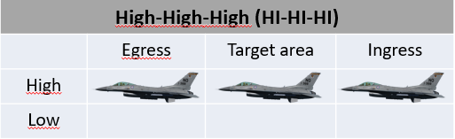 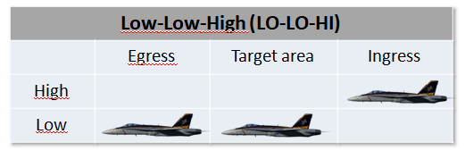

##### **High-Low-High Low-Low-Low**

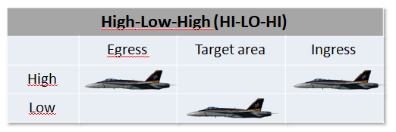 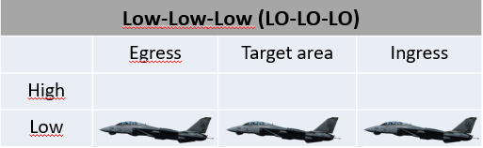

##### **High-Low-Low**

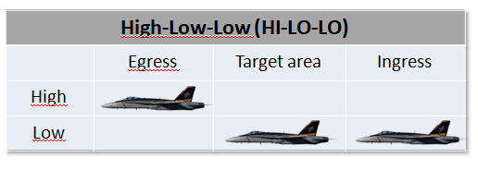

## **Low altitude tactics**

Are flown below 8,000ft AGL. Low altitude bombing can be described as bombing with height of release between 500 and 8,000ft AGL. These tactics are employed when threat system capabilities and/or weather conditions preclude aircraft operating at higher altitudes.

**Types of delivery**

**Level:** Deliver ordnance with a wings level pass over the target

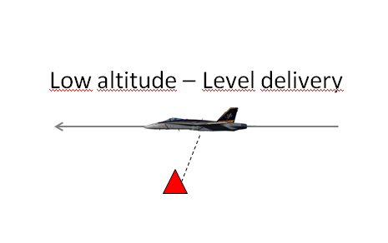

**Loft:** To execute a loft delivery, the flight proceeds inbound to the target from the IP. At a calculated point the aircrew starts a pull up maneuver to Loft the weapon. Pilot then continue to climb in preplanned angle till CCRP weapon release point. Once released, weapon continues on a ballistic trajectory while the aircrew executes follow-on tactics (Lasing) or egresses from the target area. Possition of target (coordinates) are known. Loft is non-visual bomb delivery method.

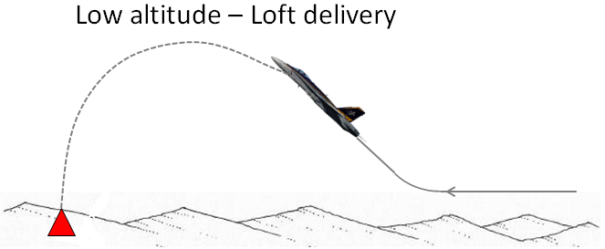

**TOSS:** is very similar to LOFT with two major differences. First, the bomb is delivered from pullup when descending direct to target. Secondly, Toss is executed when position of target is not precisely known and need to be founded and designated during first part of popup descend after APEX (visual bomb delivery method) Reason why to do this, can be distance deconfliction with exploding flyghtmemers bombs on target, or to just stay out of AAA. Both Loft / Toss are for Low Drag bombs.

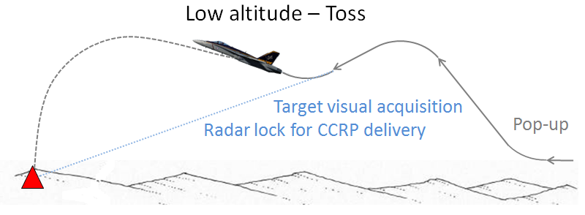

**Pop-up:** To execute a pop-up delivery the pilot proceeds to the target from the IP at low/very low altitude. When reaching desired distance from target (Action point), he will make offset turn together with climb. When at proper altitude, he will turn direct to target with desired nose down angle. When good weapon release solution shows on HUD (Gun/Rockets/Bomb), he employs weapons and procced with safe escape maneuver

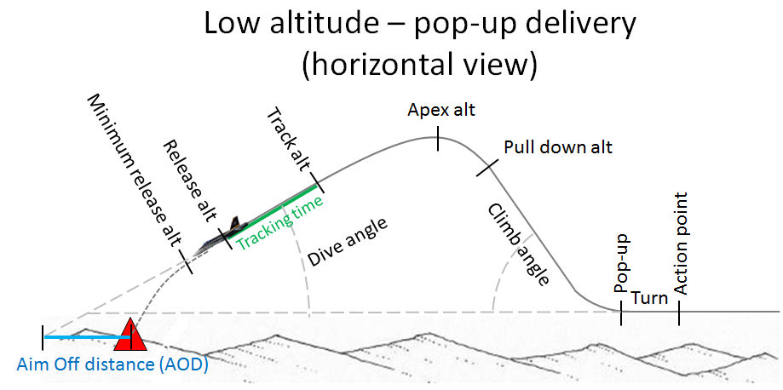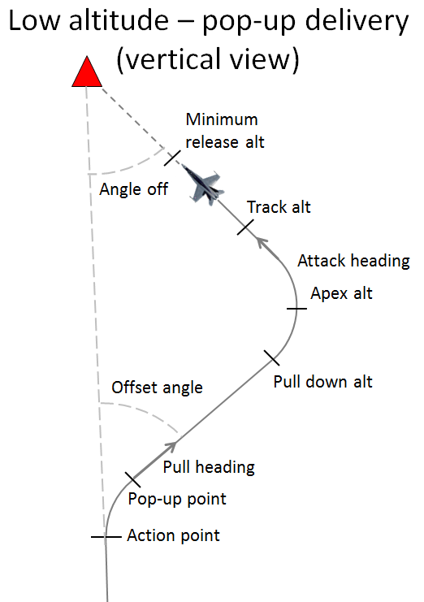

##### Pop-Up Definitions:

* + Approach Heading—The heading flown during wings-level pull-up and climb.
  + Attack Heading—The heading flown during the wings level attack. Also called the attack axis.
  + Angle-Off—The difference between approach and attack heading.
  + Direct Pop-up—Angle-off less than 15°.
  + Offset Pop-up—Angle-off greater than 15°.
  + Indirect Pop-up—Angle-off greater than 90°.

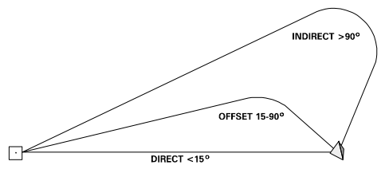

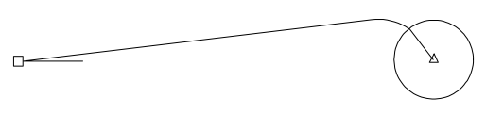

Figur 2‑1 IP Direct to PUP

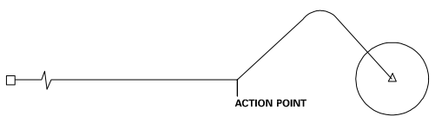

Figur 2‑2 IP Direct to Target

## **Gun deliveries**

**Low Angle Strafe (LAS)**

LAS have a planned dive angle at delivery of 15 degrees or less.

LAS deliveries are most effective against soft/lightly-armoured targets and will normally result in a higher dispersion of bullet impacts than high angle deliveries. The lower dive angle used on LAS deliveries allow for both lower aircraft speeds and operation at lower altitudes without the need for a pop-up profile, this allow the aircraft to carry out multiple passes on a single target in rapid succession and often allow the pilot to maintain visual contact with the target area throughout the attack. LAS deliveries are also ideal for attacking soft target such as supply convoys and troops.

The main disadvantages of LAS deliveries are increased exposure to enemy fire due to the low altitude and short range to the target, as well as relatively high bullet dispersion patterns resulting in reduced effectiveness against armoured targets.

Although the planned angle-off from the target can vary, normally the approach to the target is planned to be 15º–30º from the desired attack heading at a minimum of 450 KCAS. At the planned pop point, select military power and begin a 3–4 G pull-up to the desired climb angle. This is normally planned to be equal to the planned delivery dive angle plus 5º. At the preplanned pull-down altitude, roll the aircraft and begin a pull-down to achieve the desired dive angle. Monitoring the HUD pitch lines in relation to the target will simplify achieving the planned dive angle. Make an unloaded roll out with the CCIP pipper approximately 100' short of the target. After roll out, track and fire just as in a curvilinear/box strafing pass.

Different airframes open fire at different ranges. F-16s need to open fire with their 20mm cannon inside of 6500 feet slant range in order to achieve the minimum required bullet impact velocity for weapons effects.

**High Angle Strafe (HAS)**

HAS have a planned dive angle of greater than 15 degrees.

HAS deliveries will normally result in a low dispersion of bullet impacts. HAS deliveries are also ideal for point targets where a tight bullet impact pattern is desired and/or where targets are located in mountainous terrain.

The main disadvantages of HAS deliveries are a limited tracking time due to the high aircraft speed in the dive and the need for an early escape manoeuvre to recover from the dive. It can also be difficult to maintain visual contact with the target due to the requirement for a high starting altitude. The need for a high starting altitude also places the aircraft at risk of early detection and/or high risk of engagement by SAM/AAA systems during the attack.

Perform the roll in from 8000' AGL as you would for a 30° dive. At speed 500 KCAS in a typical 30° attack, open fire slant range is 6000' which requires considerable gun elevation to counter the increase in gravity drop. Since the path of the bullets is no longer flat, open-fire slant range becomes more critical. As you reach 1000' above open-fire altitude, move the pipper up to the aimpoint. Track, fire, and track until the burst is completed. Execute the recovery immediately after the gun stops firing. Do not delay to watch bullet impact.

## **Low Level Deliveries**

**Visual Level Delivery (VLD)**

The VLD is a level delivery with a release angle of less than five degrees of climb or dive; it is often performed at very low level (below 1000 ft. AGL) utilising high drag munitions such as the MK-82AIR/MK-82 Snakeeye. The minimum recovery altitude is the safe escape/fuse arm range for the ordnance being delivered, or 200 feet AGL, whichever is higher.

Unlike pop-up deliveries (see below) the VLD is flown at a near constant altitude from ingress to the end of the SEM (and normally egress). The VLD will normally be used in situations where a NOE ingress and egress is required and only one attack on the target (per aircraft) is planned. When multiple aircraft will be attacking the same target, time and heading separation is vital it order to prevent following aircraft passing through any fragmentation and deny the enemy the ability to predict the arrival of attackers.

Visual Level Delivery (VLD) (0º–5º) This type of delivery is flown using CCIP when the weather or threat precludes steeper dive angles. Ingress the target area at low altitude, terrain masking and constantly jinking until just prior to weapon release. Since your approach to the target is a random flight path, good planning is required to arrive at an action point where target acquisition is initiated and weapons delivery commenced. If a level delivery is planned, simply arrive at the target on your proper altitude with the CCIP pipper properly positioned. If a 5º diving delivery is planned, initiate a 10º pull-up followed by a pull-down/bunt approximately 500' below planned apex. Pay particularly close attention to precise release parameters, fragmentation clearance and ground avoidance. The recovery portion of this delivery must be emphasized to ensure safe escape criteria from your munition.

**LOFT**

The typical Loft delivery includes 4 G pull-up at predetermined distance from target to a 45° climb, weapons release will occur at any point that the computer sees a solution. Loft deliveries can be performed using either CCRP (or LADD for F-16) delivery modes. An immediate roll/dive recovery after weapon release is recommended. Avoid a perfect 180 degree reversal as this would ease the tracking solution for ground threat systems.

**NOTE:** Term Loft shall not be confused with Toss, which is done during a descend, not climb!

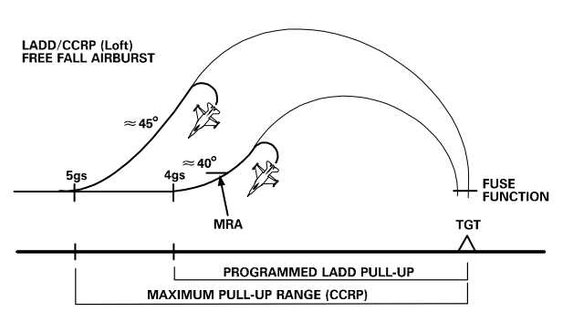

The loft delivery is usable for area targets when using area weapons or when standoff is required against short-range defenses. Accurate coordinates and system accuracy (INS, FCC, system altitude) are paramount to ensure desired weapon effects. Azimuth steering and the initial pull-up are the most critical factors in this maneuver. The FCC will still attempt to deliver the munition to the correct point over the target, but the variations become important with radar-fuzed munitions and special weapons.

##### Advantages:

* Weapon delivery takes place at standoff ranges of 2 to 5 miles from the target.
* Radar-fuzed CBU munitions can be delivered from low run-in altitude.

##### Disadvantages:

* The jet is exposed belly-up to the target area and the loft maneuver may place the aircraft in SAM engagement zones.
* Accuracy is decreased with INS navigation errors (especially non-GPS aircraft).
* Long weapon time of flight combined with wind effects results in decreased accuracy.
* Accurate target and aiming offset coordinates must be available.

The loft delivery with the TGP/LGB combination provides both target stand-off and precise guided weapons delivery. Ideally, the LGB should be lofted upon mensurated coordinates with nothing but GPS to aim the system.

## **Pop-up attacks**

**Low Angle High Drag (LAHD)**

An LAHD attack, as the name would suggest is performed using high drag munitions such as the MK-82AIR/MK-82 Snakeeye, it is also used to deliver CBUs from low level. The delivery itself is carried out with a 10º–15º degree dive angle and the minimum recovery altitude is safe escape/fuse arm for ordnance being delivered, one-half the computed altitude loss during dive recovery or 100 feet AGL, whichever is higher.

The LAHD delivery is usually performed with a low level ingress, similar to the VLD above, but rather than remaining at a constant altitude a “pop-up” is performed on the final ingress. This allows the attacking aircraft to remain at low level and utilize terrain masking (where possible) to remain out of range of any defenses at the target until the last possible moment. The aggressive nature of a pop-up followed by a dive attack further reduces the attacking aircraft’s exposure to ground fire, especially when combined with a low level egress.

LAHD is normally conducted using 10º–15º of dive. This attack maneuver is very similar to that of low-angle strafe. It is designed for low-angle delivery of high drag weapons. The approach to the target is normally planned to be made from a run-in heading offset 15º–30º from the attack heading at a minimum of 450 KCAS. At the desired pop point, a 3–4 G pull-up is initiated to the planned climb angle (usually dive angle plus 5º). At the preplanned pull-down altitude, the aircraft should be rolled towards the target and the nose pulled down to roll out just as you would in any low angle bomb delivery. Normally, this type of delivery is planned to allow 3–5 seconds of tracking/designate time prior to arriving at planned release altitude. For CCIP deliveries, roll out with the target approximately one-third down between the FPM and CCIP pipper.

**Low Angle Low Drag (LALD)**

An LALD attack is similar to the LAHD outlined above; it is also performed with a dive angle of less than 30 degrees and can be performed following a “pop-up”, although it can also be initiated from a level ingress at a higher altitude. The main difference is the weapon type used, whereas the LAHD is carried out with high drag munitions, the LALD (as the name would suggest) is performed with low drag munitions. The minimum recovery altitude is the safe escape/fuse arm height for the ordnance being employed, or 800 ft. AGL, whichever is higher.

The LALD delivery can be performed with a low level ingress and a “pop-up” on the final ingress or from a higher altitude without a pop-up. The main noticeable difference between an LALD and LAHD delivery is the altitude, at which the weapons are released, or the attack aborted, and the SEM must be carried out due to the reduced flight time and shallower flight path of the low drag munitions employed. This means that when performed with a pop-up from low level the climb is longer in duration and/or steeper.

The delivery is designed for low-angle delivery of low-drag weapons. Exercise care in computing

release altitudes to assure fuze arming and safe escape. Planned angle-off for this type of delivery can

vary from 15º–90º, although optimum angle is approximately 2 x climb angle. Accomplish pull-up to the

planned climb angle (15º + 5º and 20º + 10º) and pull-down at the preplanned pull-down altitude. Take

care to properly monitor the altimeter to determine the proper pull-down point since the apex altitude for a

LALD delivery is considerably higher than for a LAHD delivery and visual cues can be deceiving. For

CCIP deliveries roll out with the target approximately halfway between the FPM and CCIP pipper. Pay special attention to the altimeter to assure you deliver at or above the planned altitude.

#### **Dive Bombing (DB)**

The Dive Bomb delivery is probably the most familiar to the majority of pilots; it is performed with a dive angle of between 30° and 45° (60° for slow flying aircraft) degrees and from a higher initial altitude than either LAHD or LALD. The minimum recovery altitude is the safe escape, or as required to recover above 1,000 ft. AGL, whichever is higher.

The DB delivery is a very accurate method of delivering weapons using CCIP. It should be noted however that due to the higher ingress altitude terrain masking is normally impossible and extreme care should be taken in high threat environments, as the delivery will bring the attacking aircraft well inside the MANPADS and AAA WEZ. Mutual support is vital to ensuring the safety of the attacking aircraft, and wingmen should be positioned in a way that allows a clear view of the target and the attacking aircraft’s ingress, attack and egress.

**High Altitude Dive Bombing (HADB) (30º–45º)**  
This delivery is designed for high angle delivery of low-drag weapons in a high threat environment. During mission planning, aircraft configuration must be taken into account to ensure this type of approach is feasible, i.e., two wing tanks with six MK 82s may not be an option for high 45º delivery. The approach to the target is normally at 500 KCAS (minimum) to an action point 4–5 NM short of the target. At this point, a check turn between 20º–30º is required to obtain the necessary offset. At the desired pop point, a 4 G pull-up is initiated to the planning climb angle (usually dive angle plus 15º) in full AB. Once the pop-up is established, time should be devoted to target acquisition which can be difficult since you will be looking down over the canopy rail. Monitor the altimeter as the pull down altitude approaches due to the rapid climb rate to ensure correct parameters. At the apex, the aircraft will be at or nearly inverted, so care must be taken to roll out with the proper Aim Off Distance (AOD). Attacks should be planned to provide 5 seconds of tracking/designate time prior to arriving at the release altitude. For CCIP deliveries, roll out with the target approximately two thirds of the way down between the FPM and CCIP pipper. After releasing weapons, the threat will dictate the type of recovery, but for peacetime training recover with a 4–5 G pull until the nose is above the horizon then execute the egress plan.

##### Advantages:

* Increased bomb impact angle with improved penetration effectiveness over low angle deliveries.
* Increased accuracy due to slower movement of the pipper across the ground and increased radar graze angle. Baro bombing system altitude errors have less effect.
* Increased time for target acquisition.
* Radar-fuzed CBU weapons may be delivered effectively.
* Recoveries may be accomplished above some small AAA threats.

##### Disadvantage:

* Exposure to the SAM and air-to-air threat increases significantly.

**Low Altitude Toss (LAT)**

The idea of LAT delivery is to use DTOS –F16 or AUTO-F18 avionics mod at the start of the descending pop-up stage. After target designated, then perform pull up to toss the bombs and execute Safe Escape Manovers (SEM). This profile allows accurate visual deliveries of low drag munitions at standoff ranges.

##### Advantages:

* Provides lateral spacing for frag deconfliction.
* Allows standoff from several lethal defensive systems.
* Increased defensive maneuvering time against SAMs in the target area.
* Increased availability of tracking time.
* Allows considerable flexibility in meeting planned parameters.
* Eliminates problems associated with being inside the MAP/PUP.

##### Disadvantages:

* Accuracy is degraded over a CCIP delivery.
* Long slant ranges can cause difficulties with target acquisition.
* Increased exposure time but at longer slant ranges.

## **Medium/high altitude tactics.**

Are flown above 8,000ft above ground level(AGL). High altitude bombing can be described as bombing with the height of release over 15,000 ft AGL.

**Types of delivery**

**Level:** Used for guided and unguided free-fall weapons. Release point may have bomb ranges outside of visual range.

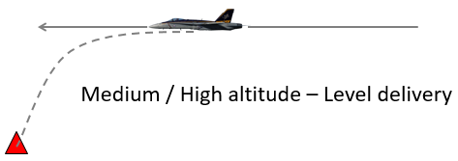

**Dive:** Used for guided, unguided and forward firing ordnance, these dive deliveries typically use dive angles of 15 to 60 degrees.

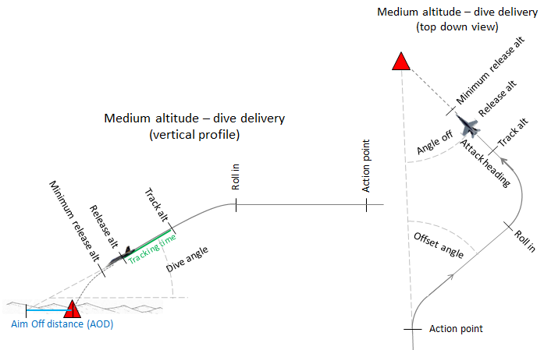

## **Medium and High Level Deliveries**

**Medium / High Altitude Loft**

Weapon delivery in which an aircraft system is used for target designation followed by a climbing and weapon release time calculated by Continuously Computed Release Point (CCRP). It should be noted that due to longer release ranges, this technique is done with precision guided weapons with one exception of nuclear weapons.

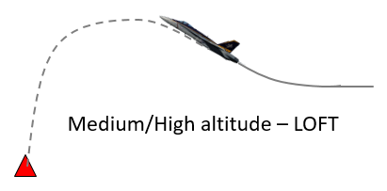

**Medium / high Altitude Level Delivery**

Delivery technique for use with Laser guided or GPS guided bombs. There is no more easy way how to drop bomb, than to just fly straight and high and at certain precomputed time (CCRP), just pres pickle button. There is one think you still need to be aware and that’s you are exposed to enemy fighters and Medium/Long Range SAM.

**High Altitude Dive Bomb (HADB)**

The HADB is almost identical to the Dive Bomb, the only real difference between the two delivery methods is the altitudes at which they are performed. Like the DB the HADB is performed with a planned dive angle of between 30 degrees and 60 degrees, but with a minimum recovery altitude of at least 4,500 ft. AGL.

The HADB, like the DB, is a very accurate method of delivering dumb munitions on target but due to the higher altitude at which it is performed it reduces the risk to the delivery aircraft from AAA or SHORADS. It should be noted that 4,500 ft. AGL is the minimum recovery altitude for the HADB delivery and pilots/flight leads can set a higher minimum recovery altitude if desired/appropriate.

When performing a HADB delivery it is vital that the pilot pays attention to the altitude and airspeed in the dive, as well as the amount of time spent tracking the target. It is all too easy to become fixated on the target, ignore the HUD and voice cues and then find yourself below the minimum recovery altitude in the range of the SHORAD systems you were hoping to avoid, or even colliding with the terrain. The tracking phase of HADB deliveries should be less than 6 seconds; excessive time spent in the dive trying to force the pipper on the target from a poorly executed dive/turn is without doubt the biggest mistake pilots make.

##### Advantages:

* Increased bomb impact angle and penetration.
* Increased time for target acquisition.
* Recoveries may be accomplished above small arms/light AAA threats.

##### Disadvantages:

* Increased exposure to SAM and air-to-air threats.
* Unpredictable weapons effects.
* Decreased accuracy with free fall munitions; especially CBU.
* Difficult to maintain visual mutual support during recovery and egress due to large altitude changes.

**High Altitude Release Bomb (HARB)**

HARB is a diving delivery with a planned dive angle of 30 degrees or greater, just like DB and HADB, where it differs is the minimum recovery altitude (and therefore the release altitude). The minimum recovery altitude for a HARB delivery is 10,000 ft. AGL, twice the height of the HADB.

Due to the high release altitude, and therefore large slant range, accuracy is limited (despite still being a CCIP delivery) which means the HARB is of limited value when attacking small, mobile targets such as vehicles and troops. It is worth noting however, that HARB may be useful in cases where it is important to get weapons on target but the threat situation makes a low level attack inappropriate. When planning such a delivery the reduced accuracy should be considered and thought given to using multiple aircraft against a single DMPI to ensure sufficient weapons impact the target in order to achieve the desired effect.

**Medium Altitude Toss (MAT)**

A MAT delivery is identical to the LAT described above but this time with no need of pop-up, since ingress already at medium altitude. The minimum recovery is the safe escape altitude/distance for the ordnance being delivered. MAT is not performed at high altitudes, since visual recognition of the target without TGP is much more difficult. If aircraft is equipped with TGP, then Level or Loft delivery is good choice.

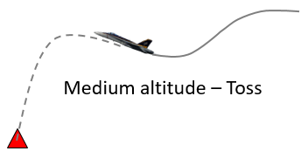

The MAT delivery has the same list of pro’s and con’s as the LAT, the notable difference being the higher altitude magnifies the effects of wind and aiming error on weapon accuracy. While the higher altitude may negate the threat posed by AAA and/or MANPADS.Iit should be considered that it makes the delivery aircraft even better target for hostile aircraft and MERAD/LORAD systems.

# **Chapter 3: Two-Ship employment considerations**

## **Pilot roles and assignments**

##### Shooter:

Primarily responsible for putting munitions on target.

##### Cover:

Responsible for providing mutual support to the other flight member. Specific requirements for this role will be briefed by the flight lead.

##### Eyeball:

Eyeball is assigned to a pilot who will employ the TGP during the attack. Pilots assigned this role can expect to mark the target with the laser and/or IR marker for target identification purposes and/or LGB guidance.

##### Decoy:

Flight member’s primary responsibility is to create confusion, deny or delay enemy defences to keep them from engaging the attacking aircraft.

#### Shooter-Cover

Here the  shooter will focus on target acquisition and release of weapons whilst the other  aircraft flying ing a cover role will support the shooter by:

-Scanning  visually for  threats (smoke  trails, traces, muzzle  flashes)

-Scanning  the RWR and Radar

-Immediately  call threats to  the other aircraft,  and a directive on how  to defeat the threat

#### Shooter-Shooter

These are  attacks where  both aircraft fire  weapons during the same  attack run. This attack type  is generally reserved for “stand-off”  weapons such as Mavericks, where the attacking  flight does not overfly hostile ground or fly within  the engagement envelope of the target. I.e., the flight  performs a trade-off between the security offered by having  a dedicated supporting fighter and added firepower in a single  run.

Shooter-shooter  attacks are typically  conducted from Line abreast, Wedge or  Fighting Wing.

Shooter shooter attacks can also be spaced out with a time separation (For example “shooter-shooter, 30 sec spacing”).

#### Shooter- Decoy

This is primarily used against enemy Air Defences where one aircraft uses itself as bait for the air defences, for examply by having a SAM lock the decoy aircraft up, and fire against the decoy aircrafts allowing the shooter to operate inside the Weapon Engagement Zone (WEZ) without being shot at.

#### Shooter-Eyeball

WILL BE ADDED LATER

## **Low Altitude two ship tactics and deconfliction**

When adding a second aircraft to an attack, we encounter complications due to frag and aircraft deconfliction. When multiple aircraft are tasked to attack a target and TOT compression is desired, a potential flight path and fragmentation conflict exists. The fragmentation problem depends on type of ordnance, delivery profile, and number of aircraft attacking the target.

##### Deconﬂiction Options

We have three basic deconflictions for low altitude tactics:

1. Altitude separation, the ﬁrst aircraft can use a level, low-angle pop-up, VLD delivery, offsetting as necessary for the planned delivery. The second aircraft splits at a predetermined point and pops to a high LALD or dive bomb delivery and pulls out above the frag envelope.
2. Distance deconﬂiction, the second aircraft can use LAT or a loft delivery pulling out with separation from the frag.
3. For timing separation a split at sufﬁcient distance to achieve the desired spacing is effective but reduces mutual support after the split. A split closer to the target requires arcing to remain within visual range and achieve timing separation. This allows the second aircraft to drop from a low-altitude delivery. The distance of the arc from the target depends on the turning room necessary to achieve delivery parameters.

### Single or double attack directions

In hight threat area, the splitting air defences also may be usefull. If threat is considered as not that high and mutual support in formation have higher priority, than Echelon attack is good choice.

##### Split Pop Attack

This option is designed for minimum exposure while splitting the defenses. Deconﬂiction can be achieved through altitude, distance, or timing.

**WARNING:** Altitude deconﬂiction may put the wingman into the heart of some threats. Use altitudes that recover above the threat versus frag to the maximum extent possible.

##### Echelon Pop Attack

An echelon pop has both aircraft offset to one side of the target. This attack allows the element to maintain visual contact during the ingress, and allows the wingman to ﬂy a visual formation during the attack. Deconﬂiction can be achieved through altitude, timing, and distance. Both aircraft turn away from the target at a predetermined point for offset pops. The lead aircraft can use a minimum exposure delivery such as VLD. The second aircraft can achieve altitude separation by popping to a high LALD or dive bomb delivery and pulling out above the frag.

**WARNING:** Altitude deconﬂiction increases the wingman’s vulnerability to many threats. The requirement for high power settings (AB) and long unmask times allows threat acquisition and engagement. Use altitudes that recover above the threat versus frag to the maximum extent possible.

### Time deconfliction

Time separation between aircraft deliveries must be equal to or greater than the time the preceding weapon's fragments are in the air, plus the delivery TOF of the preceding munition. To ensure frag deconfliction from the last weapon in the string, attack intervals should include the time required for the ripple/train release.

We have two possible menovers to achieve Timing separation. **A split closer to the target requires Arcing** to remain within visual range and achieve timing separation. This allows the second aircraft to drop from a low-altitude delivery. The distance of the arc from the target depends on the turning room necessary to achieve delivery parameters. Other method is to use 90/90 spacing menover 2 minutes prior target – this will lead into Trail attacks.

#### Trail Attacks

A trail attack provides timing deconﬂiction but gives up visual support for the second aircraft during ingress. 4 to 5 nm trail formation can be achieved by a spacing maneuver such as a 90/90 or by airspeed. Both aircraft use deliveries such as VLD or Loft that minimize exposure to the terminal threats. The ﬁrst aircraft breaks away from the target after release with the second aircraft watching for SAM launches. To provide visual support for the second aircraft, the ﬁrst aircraft turns back across the ingress heading. This helps to reacquire the second aircraft while beaming the threats.

Line abreast to a trail formation of 4-5 nm using a 90/90 maneuver:

* The wingman turns 90° off the ingress heading for approximately 20 seconds.
* After 20 sec, the flight leader should have traveled 5 nm and the wingman then turns back to the Target.

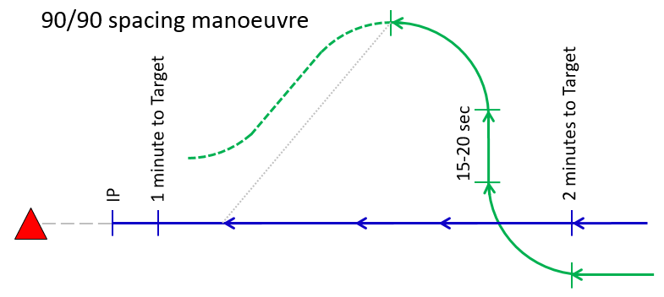

##### Advantages:

* A more flexible attack is possible if navigation accuracy or target acquisition is questionable.
* Subsequent flight members can bomb off of lead’s bomb impact.

##### Disadvantages:

* The wingman flies single-ship close to the target area.
* The flight strings out, which reduces visual mutual support and complicates post-attack rejoin.
* Too much turning near the terminal threat area.
* Disorienting to the wingman requiring a 90° turn to the target.

## Loft Attacks

Loft deliveries allow weapons to be delivered simultaneously. In case of a degraded system aboard one aircraft, a loft can be made on the wing. Another option is the individual loft delivery.

### Simultaneous Loft

Both aircraft loft the ordnance from wedge. The formation should be spread 6,000 to 9,000 feet to compensate for convergence during the loft maneuver. Prior to pull-up, the wingman centers up the computed steering displayed on the HUD. An immediate roll or dive recovery after weapon release is recommended. Avoid a perfect 180-degree reversal as this would ease the tracking solution for ground threat systems.

##### Advantages:

* The laterally spread formation causes confusion for ground threats.
* Provides stand-off from target area threats.
* Each F-16 has independent loft accuracy.
* Egress formation can be established quickly.CHAPTER 5-90

##### Disadvantages:

* Accurate deliveries may not be possible.
* Target coordinates may not be accurate.
* No good against mobile targets.
* Requires accurate system.
* Relatively good weather is necessary to maintain visual formation during pull.
* Mutual support is limited during the loft maneuver.

### Loft on the Wing

One aircraft may be required to bomb using the computed solution of the other aircraft due to system malfunction or weather constraints. In this case, the wingman ﬂies within 500 feet of the lead aircraft, matches the pitch rate during the pull-up, and manually releases weapons in sequence with the leader's release.

### Trail Loft

The wingman is positioned approximately 3 NM in trail. This distance puts ordnance on target for a longer time period and reduces the potential for conﬂict between the leader's egress maneuver and the wingman's loft maneuver. Lead should call the direction of break off after delivery if this has not been prebriefed.

## Laser Maverick (LMAV) (Left / Right) Attack

We have 4 simple steps to deliver LMAV:

1. CAPTURE

* Estabilish on 20° ramp
* Uncage missile seeker
* Ensure scan pattern starts

1. OPTIMIZE

* LASER lock-on occurs (Solid square GPI)
* Center GPI in Launch Contraint Circle
* Expandables passing through sanctuary

1. ATTACK

* ROE satisfied
* Solid square GPI within Launch Contraint Circle
* Fire: pickle button depress

1. EGRESS

* Off-Target Maneuver
* Expandables passing through horizon
* Climb to sanctuary or avoid overflight of target area

To execute an LMAV attack utilizing the standard 20 degree ramp profile.

1. Ingress altitude: 14,000 ft

2. Ingress airspeed: 400 KTAS

3. 20 deg ramp

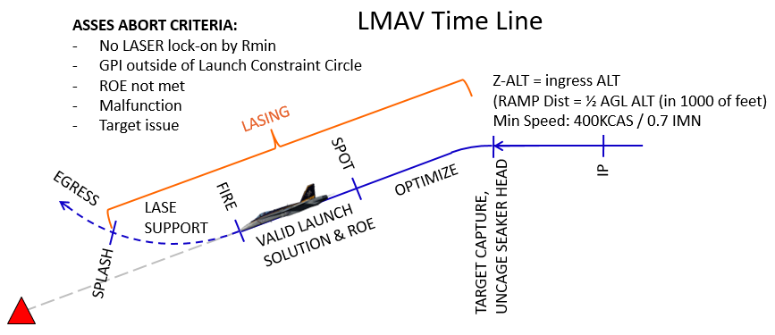

## Off-Target Priorities

There are several tasks to accomplish once you have pickled. Be sure to prioritize flying the jet first as always.

**Valid Climbing SEM**

Your first priority after weapon release is a valid SEM. The mechanics and parameters of the climbing SEM remains the same as the BSA pattern. Realize that the purpose of this maneuver is to keep you safe from the ground, the frag of your own weapon, and to get you away from threats in the area as quickly as possible. In the IFF SAT environment, there are no simulated threat reactions, but you should start practicing clearing your six, maneuvering three dimensionally, and flying the briefed geometry to help regain the visual and get back to a mutually supportive formation.

**Clear Your Six**

Use preemptive CMD to decoy IR and radar threats. In all cases, your primary defense against anti-aircraft artillery (AAA) is three-dimensional maneuvers. In a medium-altitude (low-threat) environment, your climbing SEM will already have you moving in two dimensions; some minor check turns left and right while you climb back to hold altitude will suffice. Be sure not to bleed too much airspeed and get yourself to a low-energy state so that if a threat does become a factor, you have some energy to react to it.

**Find Your Flight Lead**

Expect lead to be between your 10 and 2 once you have turned 60° to 90° off of the attack heading. You will be assumed blind off target. Your lead will typically give you a few seconds following your SEM to move your jet IAW the contracts and to find him. If you don’t find him (or don’t call it) in a timely manner, he will talk your eyes back on. He should also give you a basic altitude deconfliction plan in the brief if you are blind for an extended period of time. Remember to continue flying the geometry briefed even if you don’t see lead and maintain the altitude deconfliction. In other words, turn back into the wheel around 3 miles vice extending several miles outside the fight.

**Get Back into Position**

Even with an 8,000-foot hold, you will find yourself low on energy when trying to get back into formation on lead. Remember that a good SEM will increase your energy. Beyond that, the best you can do is keep the power in MIL and use geometry/cutoff to regain correct distance from Number 1.

# **Chapter 4: Useful information**

## **Three Point Attack Brief**

The Three-Point -Attack  Brief is the standard  attack briefing designed to  give the information needed to  perform an attack quickly. The brief assumes that as a minimum the engaged fighter has acquired the  target, and is the minimum information considered necessary to execute an attack:

**Initial Point (IP)**

The point from where the attack starts. Can be a waypoint, geographical feature or a holding area (wheel, racetrack). If no information is given, the attack is conducted from formation.

**Method of Attack**

Roles, Attack formation, and type of attack, weapon.

**Egress**  
Safe escape maneuver, egress direction or point. Can be a heading or a point like IP,and can contain  instructions for additional  attacks using the same brief.

## **Fence Check**

“FENCE IN” is  a cockpit switch  check to confirm that  all onboard systems and  profiles are set up for combat.  Think “jumping over the fence” and  into enemy territory.

“FENCE  OUT” is  conducted to  de-arm and check  the aircraft for damage  and hung stores after the  conclusion of combat operations.

FENCE  checks are  typically conducted  before the flight arrives  at or leaves its check-in point.

Set  the systems  according to pre-briefed  values if available.

|  |  |  |
| --- | --- | --- |
| **F** | Fire control  systems: | A-A/ A-G Mode, Stores page and weapon profiles, EO timer , IR Cooler and MASTER  ARM |
| **E** | Electronic  Warfare: | Countermeasures, ECM, RWR, |
| **N** | Navigation  Systems: | HSI set, fuel  quantity, fuel |
| **C** | Communications Radios: | On correct  preset/frequency , IFF, Datalink (SA page) |
| **E** | Emitters: | TACAN, Radar  and external  lights |

### **Mutual support Attack Geometry**

Cover pilots must consider the attack geometry when attacking from a medium altitude in order to provide continuous mutual support. Monitor the target area and “shooter” while maintaining turning room so you can roll-in if called upon to employ munitions. The most critical part of mutual support during an attack and recovery is visual. It is difficult for the attacking aircraft to clear its 6 o’clock while maneuvering off the target because of the higher delivery altitudes. Two methods to help reduce loss are:

#### Arcing the Target

As the “shooter” rolls in the cover aircraft continues to arc the target. You must arc far enough away so the entire target area can be seen but close enough to maintain a visual on the “shooter” aircraft during roll-in and recover. A good technique is to keep the target area on the canopy rail, this permits a dive angle of approximately 45° if required to roll-in. When in trail or wedge prior to roll-in it will be difficult to use this technique since the “shooter” will be traveling away from your aircraft’s position. When possible, the cover aircraft will art toward the direction of the pull-off location of the “shooter.

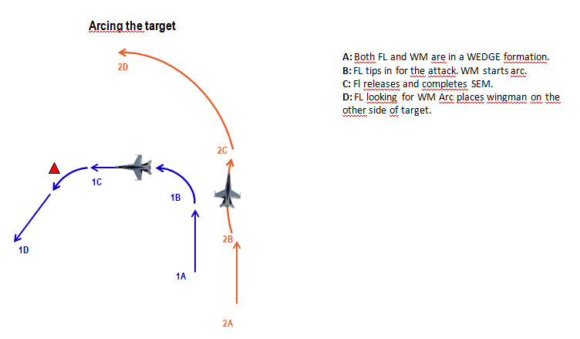

#### Parallel Attack Axis

Similar to Arcing, the different is the “shooter” provides a verbal cue to clear the cover aircraft to maneuver parallel the attack axis. The verbal cue will be briefed prior to the attack either on the ground or in the air. The cover aircraft establishes a position to employ ordnance and monitor the target area and “shooter” during roll-in and pull-off. When the “shooter” pulls-off the cover aircraft will be in a predictable point aiding the “shooter” regaining visual. This will minimize “Blind” calls from the “cover” or “shooter.”

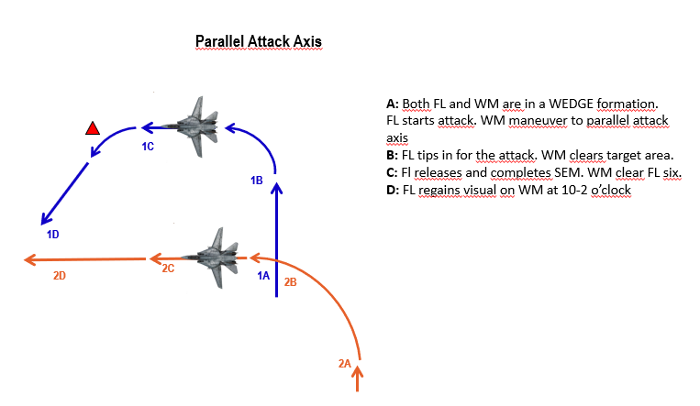

#### **High/medium altitude tactics**

#### Shooter-Cover

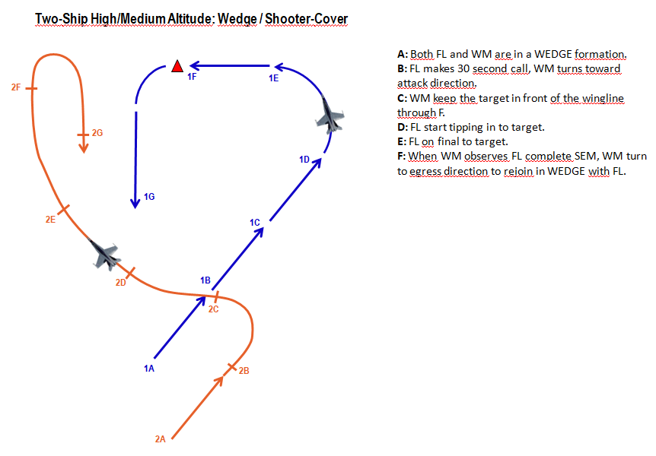

Shooter-Shooter

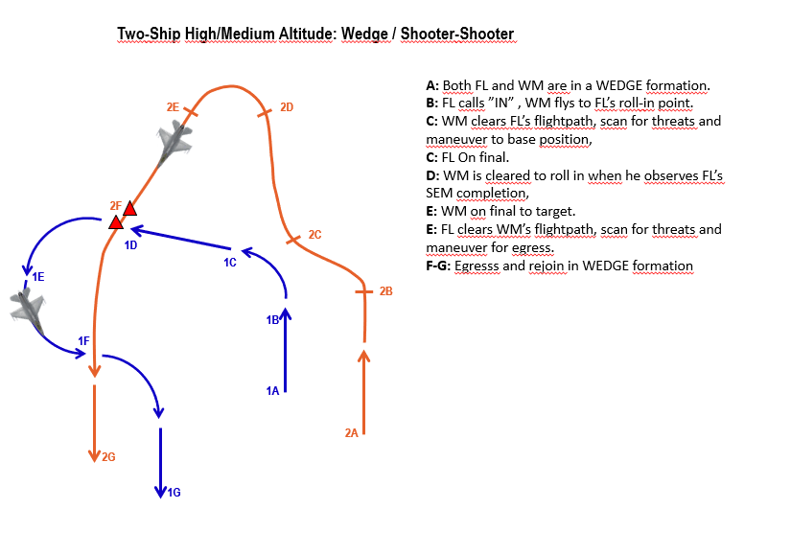

##### Two-ship high/medium altitude: Line abreast , standoff attack/ shooter-shooter

##### 

#### **Low altitude tactics**

#### Shooter-shooter

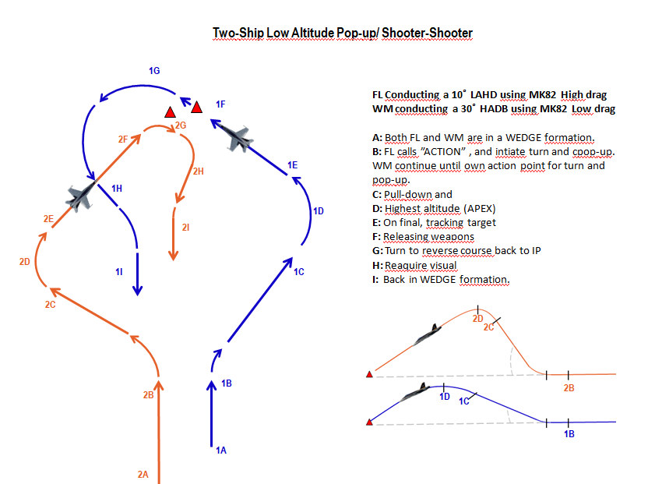

Figure 4‑1: In this attack FL have a actionpoint 5,1 nm away from the target, flying at a speed of 500kts at 400ft AGL. At Action, FL does a 20 degrees right turn, and conducts a 3-4 G pull to 15 degrees with full AB. APEX at 1700ft AGL (target altitude). WM have a actionpoint 5,1 nm away from target, flying at 500kts at 400ft AGL. At Action, WM does a 30 degree right turn and conducts a 4G pull to 45 degrees with full AB. APEX at 5800ft AGL (target altitude).

##### Two-ship low altitude: Line abreast, Maverick attack / Shooter-Shooter

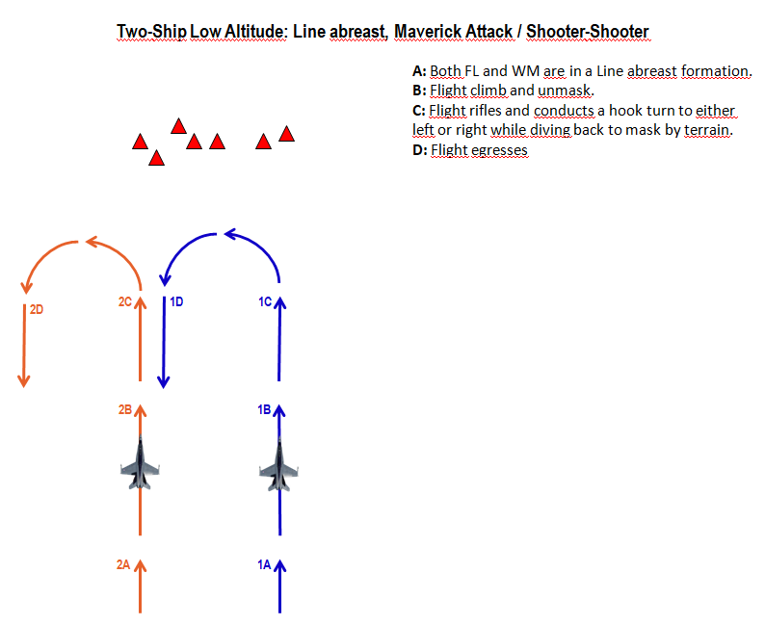

## **Buddy lasing**

WILL BE ADDED LATER

## **Ground lasing**

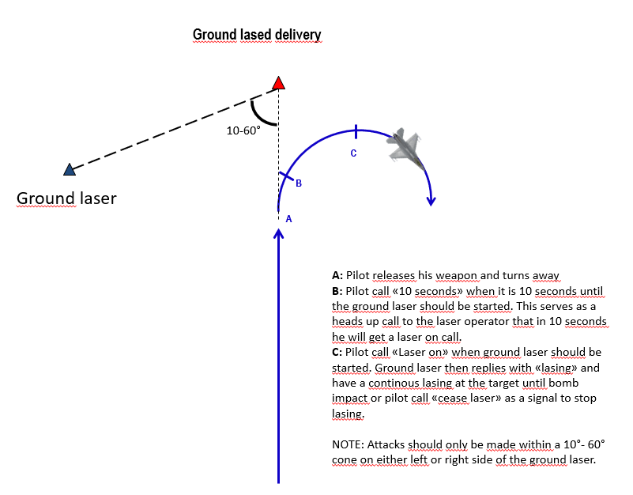

## **Holding patterns**

At times it may be necessary to hold at a specific point, or area in order to

When possible the flight should hold in a area with enough airspace to hold in an area of relatively low AAA/SAM activity that also provides a good position to observe the target area.

Racetrack: An oval holding pattern with straight legs and with standard 180 degree turns on each end. Racetrack is anchored into a fix which can be TACAN or waypoint or a geographical feature.

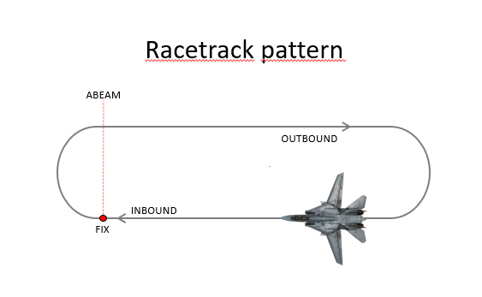

Figure Eight: The same as racetrack pattern except the turns at each end of the pattern are made toward the target area or a fix and are 230 degrees of turn instead of 180 degrees.

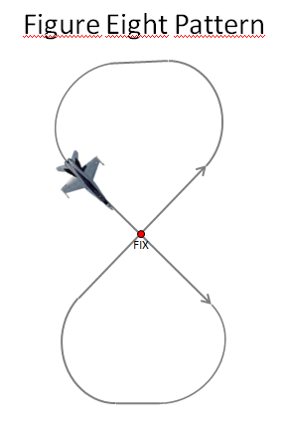

Wheel orbit: Circle around the designated target or a fix. Appropriate for nonlinear battlefields with pockets of enemy activity

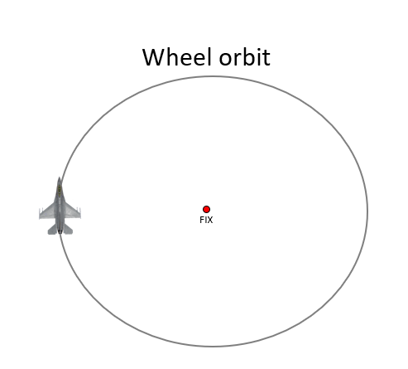

## **Range pattern**

### Conventional Pattern

Purpose. The conventional pattern allows orderly, repetitive weapons delivery practice for up to four aircraft on the range. It is designed to allow you to get from one pass to the next as efficiently as possible to maximize learning basic diving weapons delivery.

Conventional Pattern Overview. The conventional pattern is similar in structure to a standard landing pattern, with the following segments: crosswind, downwind, base, and final (Figure 5.2). While the basic pattern remains the same between different events, altitude and base position will change to accommodate the various release altitudes and dive angles. Depending on the event, a complete “lap” around the pattern will take only 1 to 2 minutes or about 100 to 150 pounds of fuel. In addition to the required tasks for each segment of the pattern, you will have to maintain briefed altitude, airspeed, and ground track.

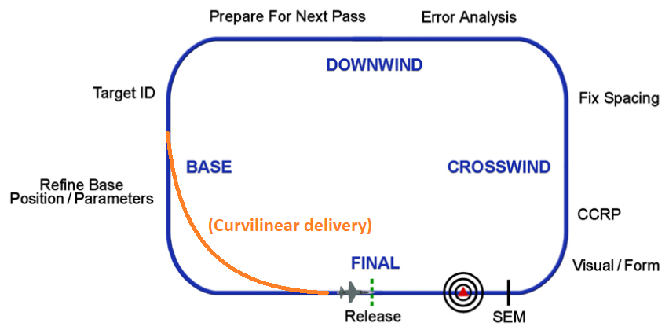

Curvilinear deliveries are used primarily for delivering ordnance from shallow dive angles at relatively low release altitudes (Figure above). The use of shallower dive angles and lower release altitudes may be necessitated by the type of ordnance being delivered, weather in the target area, or other tactical considerations. A curvilinear approach consists of constantly changing heading, altitude, airspeed, and G loading to arrive on final for a short tracking solution, thus decreasing AAA hit probability. It may consist of almost any flight path which will allow you to get from roll-in altitude to wings level on final at the planned track point. The most common technique is a descending turn in 30º–60º of bank using MIL power initially. Approaching desired release airspeed, retard the throttle as required to hold airspeed. Play the last half of the turn to arrive on final with the bomb fall line through the target for CCIP deliveries. For DTOS deliveries fly the TD box to, or just short of, the target. Cross-check your parameters and make any adjustments necessary to meet your planned release minimums. Designate/pickle and initiate the recovery. This technique is good for LAS, LAHD, LALD, and LLLD deliveries.

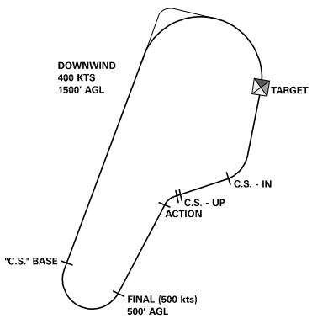

### Tactical Pattern

Purpose. Like the conventional pattern, the tactical pattern allows “canned” delivery pattern training. In the tactical pattern you will perform popup attacks. Popup attacks are flown when weather or threats force you to ingress the target at low altitude.

Tactical Pattern Overview. There are two types of pop patterns that are flown in BSA: direct and indirect. Direct pop patterns involve a run-in directly to the target followed by an "action" where a turn is made a specific distance from the target to create an offset prior to rolling in. An indirect pop pattern is constructed so that the offset heading is flown immediately after rolling off of the base position. Both attacks allow for target acquisition during the pop and subsequent pulldown to a diving attack.

### **Safe Escape Maneuvers (SEM)**

**Level Straight Through (LST)**

This is the simplest of the SEMs and is exactly what its name suggests; safe escape is provided by a level, constant speed, no-turn profile. Maintain this SEM until 3 seconds after the TOF of the last bomb in the stick. This is only used with a level release, like the VLD you might use with MK-82AIRs.

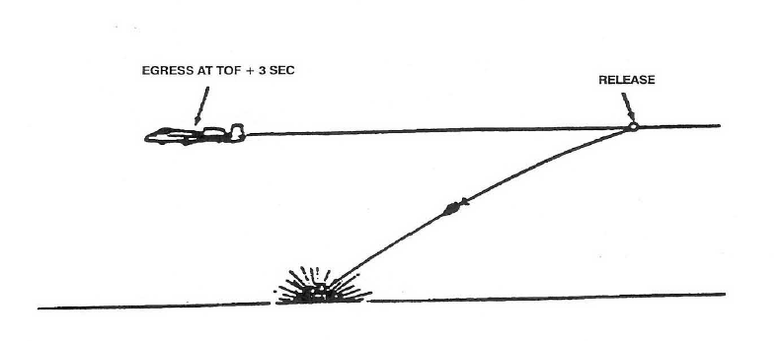

**Turning (TRN)**

It's valid for attacks using up to 20° of dive. After release, simultaneously apply MIL and establish a 4g loaded roll (60-85° of bank) in the desired direction. As the FPM nears 5° of dive increase your bank angle to maintain 4g and 5° of dive for at least 60° of heading change.

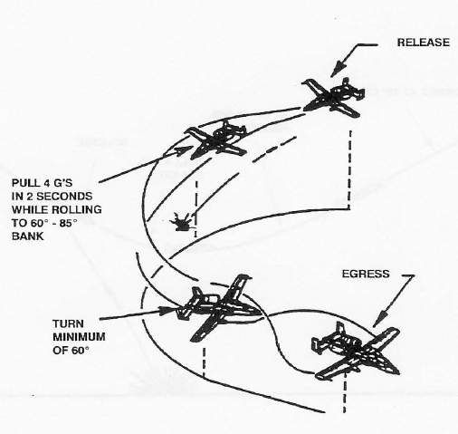

**Turning Level Turn (TLT)**

This is also used for deliveries with up to 20°. After release, simultaneously apply MIL power and establish a wings-level 4g pull within 2 seconds. As the FPM nears the horizon, perform a 2-4g loaded

roll in the desired direction and establish a 4g level turn for at least 60° of heading change.

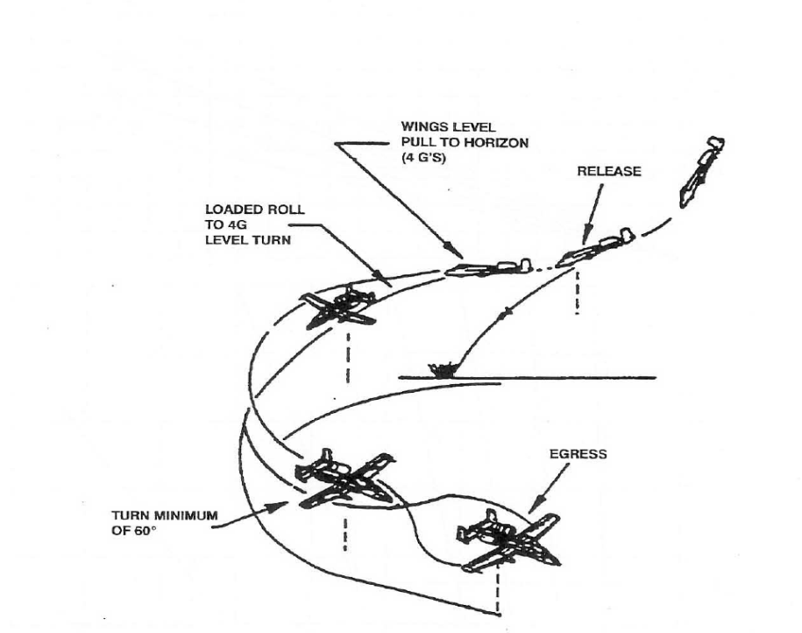

**Climb (CLM)**

The CLM SEM can be used for attack profiles with as much as 60° of dive. After weapon release, establish a 4g pull within 2 seconds. As the nose approaches the horizon, apply MIL power and maintain the 4g pull until the FPM is 20°above the horizon, and then relax the pull until the FPM indicates at least a 30° climb.

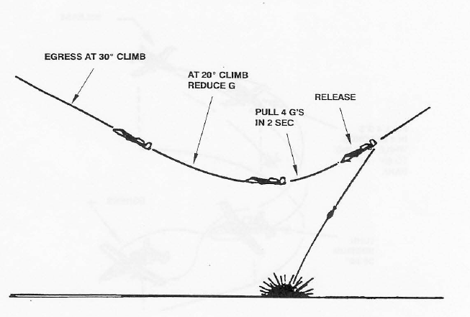

# **Chapter 4: Z-Diagrams**

##### Z-Diagram explanation Pop-up attacks

This is the maximum altitude during the attack

What kind of profile is shown

This is distance is the action point, where the turn to either side is initated

This is how many degrees to either side is the offset before doing the pull-up

How many degrees is the pop-up.

This is the Planned Release Altitude. Also gives the Minimum release Altitude

This is the dive angle during final

At what altitude should the pilot start his roll-in / pull-down toward target

This is the minimum altitude during the profile

##### Z-Diagram attack profiles High altitude and Medium altitude dive bombs

### 

What kind of profile is shown

### 

What altitude to be at when flying the base-leg

This is the dive angle during final

Speed at weapon release

What speed to be at while flying at the base-leg

Distance at when to tip-in while flying base-leg (Slant range)

This is the minimum altitude during the profile

This is the Planned Release Altitude. Also gives the Minimum release Altitude

## **Z-Diagrams 494th**

##### Z-Diagram attack profiles Pop-up attacks

#### Low Angle Strafe

#### High Angle Strafe

#### 10˚ Low Altitude High Drag (LAHD)

**30˚**

**15˚**

**10˚**

**10 LAHD**

**2.1K AGL**

**1000ft AGL**

**(800ft AGL)**

**300ft AGL**

**500 KCAS**

**2,9 NM**

**1.6K AGL**

**Ingress 200ft, 450KTS**

**Pulling G’s = 4.5g**

**Tracking time = 5s**

**Aim Off Dist = 2687 ft**

**Offset Angle = 20°**

*20˚ Low* *Low Altitude High Drag (LAHD)*

**40˚**

**30˚**

**20˚**

**20 LALD**

**4.2K AGL**

**2000ft AGL**

**(1800ft AGL)**

**1000ft AGL**

**500 KCAS**

**3,1 NM**

**3.1K AGL**

**Ingress 200ft, 450KTS**

**Pulling G’s = 4.5g**

**Tracking time = 5s**

**Aim Off Dist = 1353 ft**

**Offset Angle = 35°**

#### 30˚ Low AltitudeLow Drag (LALD)

**45˚**

**40˚**

**30˚**

**30 LALD**

**6.2K AGL**

**3000ft AGL**

**(1800ft AGL)**

**1000ft AGL**

**500 KCAS**

**3,3 NM**

**4.8K AGL**

**Ingress 200ft, 450KTS**

**Pulling G’s = 4.5g**

**Tracking time = 5s**

**Aim Off Dist = 1102 ft**

**Offset Angle = 40°**

### Low Altitude Toss (LAT) - (10 second tracking at 30 LALD)

**45˚**

**40˚**

**30˚**

**LAT**

**8.3K AGL**

**3000ft AGL**

**(1800ft AGL)**

**1000ft AGL**

**500 KCAS**

**4,0 NM**

**7.0K AGL**

**Ingress 200ft, 450KTS**

**Pulling G’s = 4.5g**

**Tracking time = 10s**

**Aim Off Dist = 1102 ft**

**Offset Angle = 40°**

### Low Altitude 40° LOFT

**40˚°**

**40 LOFT**

**500 KCAS**

**4,0 NM**

**3.5K AGL**

**Ingress 200ft, 550KTS**

**Pulling G’s = 4.0g**

#### 40˚ High Altitude Dive Bomb (HADB)

**35°**

**40°**

**40 HADB**

**2.1k AGL**

**8 000 ft AGL**

**(6 000 ft AGL)**

**4 000 ft AGL**

**500 KCAS**

**8,0 NM**

**450KCAS**

**Pulling G’s = 4.0g**

**Tracking time = 10s**

**Aim Off Dist = 6078 ft**

### 40˚ High Altitude Release Bomb (HARB)

**35°**

**40°**

**40 HARB**

**2.1k AGL**

**12 500 ft AGL**

**(12 000 ft AGL)**

**10 000 ft AGL**

**500 KCAS**

**8,0 NM**

**450KCAS**

**Pulling G’s = 4.0g**

**Tracking time = 5s**

**Aim Off Dist = 6078 ft**

## **Z-Diagrams 388th**

##### Z-Diagram attack profiles Pop-up attacks

##### Z-Diagram attack profiles High altitude and Medium altitude dive bombs

## **Z-Diagrams 108th**

##### Z-Diagram attack profiles Pop-up attacks

##### Z-Diagram attack profiles High altitude and Medium altitude dive bombs